JECRC
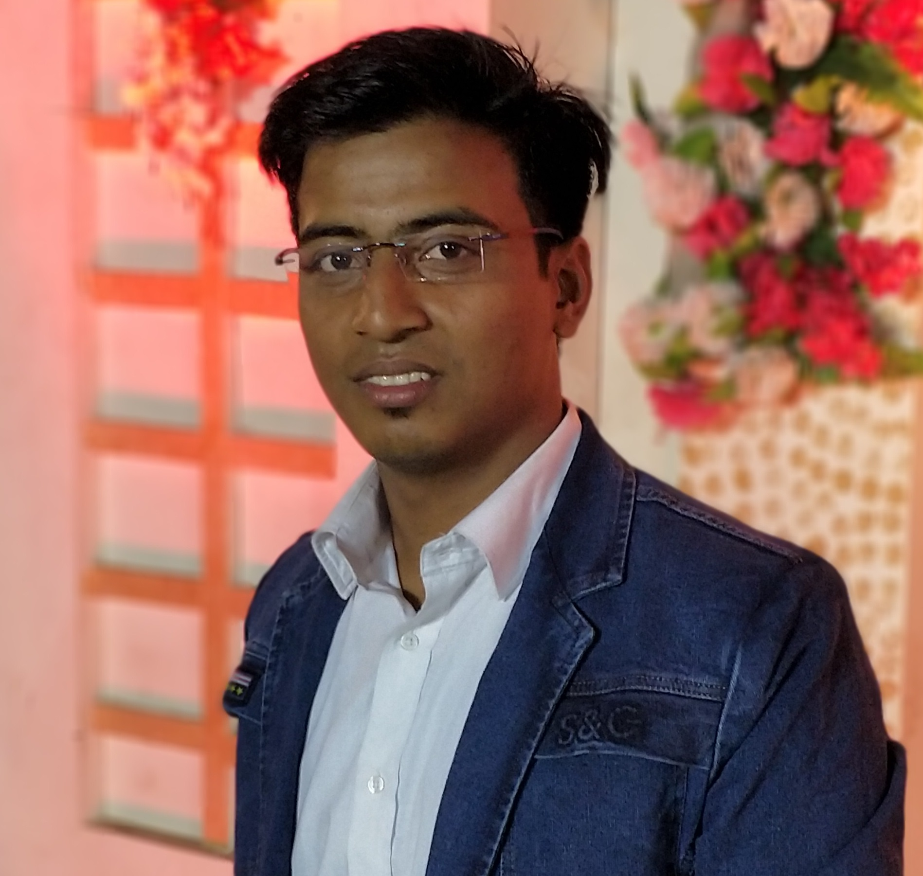
JAIPUR

INDIVIDUAL FACULTY DATA SHEET
Name of the faculty member | : Rahul Kumar Malee
Present Designation | : Assistant Professor
Email Id: rahulkumar.ee@jecrc.ac.in

Contact Details: +919785845882

I. Particulars of Educational Qualification: (only completed)
Category | Name of the Degree | Specialization | Year of Passing | Name of the College | Name of the University
UG | B.Tech | Electrical Engineering | 2014 | SKIT Jaipur | Rajasthan Technical University
PG | M.Tech | Power System | 2016 | MNIT Jaipur | MNIT Jaipur
Ph.D.

II. Academic Experience : 2 years

III. Industrial Experience : NIL

IV. Title of Ph.D. Thesis :

V. Awards/Achievements :

VI. Research/Specialization : distribution system expansion planning, electricity market

VII. Course Taught :

VIII. Refereed International Journal Publication : 01

IX. International Conference Proceeding :02

X. Books Written :

XI. M.Tech Thesis Guided :

XII. PHD Thesis Guided :

XIII. Professional Body Membership : IEEE student membership

